SPRINT-4 PYTHON CODE

|  |  |
| --- | --- |
| DATE | 4November 2022 |
| PROJECT TITLE | REAL TIME RIVER WATER QUALITY MONITORING AND CONTROL SYSTEM |
| TEAM ID | PNT2022TMID14052 |

**CODE**

#importing Random function to generate the value import random as rand

for i in range(5): print("Test case:",i+1)

print("Welcome to Real-Time River Water Quality Monitoring and Control System") temperature = int(rand.randint(-40,125)) pH = int(rand.randint(0,14)) DO = int(rand.randint(0,100))

TSS = int(rand.randint(0,3700)) Manganese = int(rand.randint(0,1000))

Copper = int(rand.randint(0,2000)) ammonia_Nitrate = int(rand.randint(0,100)) Hardness = int(rand.randint(0,1000))

Zinc = int(rand.randint(0,100))

Conductivity = f"{float(rand.uniform(0.001,2000)):.2f}" Chloride = int(rand.randint(0,200))

Sulphate = int(rand.randint(0,1000))

#These variables store value of ramdom data to be shared to the cloud #printing the values

print(

"Temperature:", temperature, "\npH:", pH,

"\nDO:", DO,

"\nTSS:", TSS,

"\nManganese:", Manganese, "\nCopper:", Copper,

"\nAmmonia & Nitrate:",ammonia_Nitrate, "\nHardness:",Hardness,

"\nZinc:", Zinc, "\nConductivity:", Conductivity, "\nChloride:", Chloride, "\nSulphate:", Sulphate, "\n"

)

OUTPUT

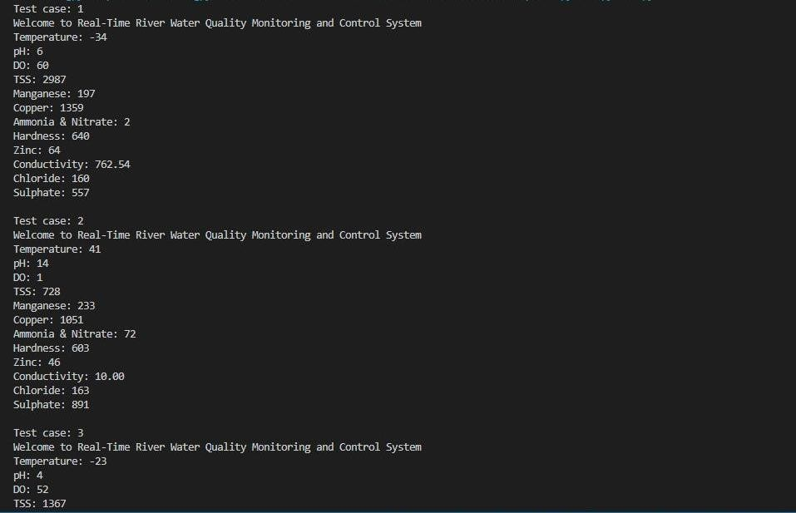7

